# **Day 6 - Deployment Strategy and Staging Environment Setup**

### **Clothing E-Commerce Website**

**Submitted by:** Ayman Shaheen  
**Roll No:** 00476421  
**Class Day:** Sunday Morning

## **1. Objective**

The goal of this phase is to **deploy the Clothing E-Commerce Website** to a **staging environment**, ensuring all configurations, optimizations, and security measures are in place before the final production launch. The staging environment serves as a **pre-production testing ground** to evaluate **performance, responsiveness, security, and user experience** under real-world conditions.

## **2. Project Resources**

🔗 **GitHub Repository:** [Ayman’s GitHub](https://github.com/Ayman-queen)  
🔗 **Staging Website:** [Live Preview](https://figma-to-nextjs-ecommerce.vercel.app/)  
🔗 **Figma UI Design:** [Figma Template](https://www.figma.com/design/YUR8kary0dXj39RSTmNolR)

## **3. Deployment Workflow & Environment Management**

### **Understanding Deployment Environments**

| **Environment** | **Purpose** |
| --- | --- |
| **Development (DEV)** | Internal testing, coding, and debugging. |
| **Staging (STG)** | Pre-production testing to validate real-world performance. |
| **User Acceptance Testing (UAT)** | Final validation phase before public release. |
| **Production (PROD)** | The live version available to end-users. |
| **Disaster Recovery (DR)** | Backup environment to prevent system failures. |

## **4. Steps to Deploy and Set Up the Staging Environment**

### **Step 1: Choose a Hosting Platform**

✅ Selected **Vercel** for smooth **Next.js deployment**.  
✅ Connected **GitHub repository** to enable **automatic updates** on code push.  
✅ Configured **build settings and deployment scripts**.

### **Step 2: Securely Configure Environment Variables**

✅ Created a .env file to store **sensitive API keys** securely.  
✅ Uploaded variables to **Vercel's environment settings**.

**Example .env File:**

NEXT_PUBLIC_SANITY_PROJECT_ID=your_project_id

NEXT_PUBLIC_SANITY_DATASET=production

API_SECRET_KEY=your_secure_api_key

### **Step 3: Deploy the Application to Staging**

✅ Successfully deployed the **Clothing E-Commerce Website** to **Vercel's staging environment**.  
✅ Checked **deployment logs** for **build errors** and **warnings**.

## **5. Staging Environment Testing & Validation**

### **Functional Testing**

✔ Ensured product listings **load dynamically** from the API.  
✔ Verified that filters, search, and sorting work as expected.  
✔ Checked cart and checkout functionalities for **accuracy in price calculations**.

### **Performance Testing**

✔ Used **Google Lighthouse** for performance audits.  
✔ **Page Load Time:** 1.5s (Optimized images & minified assets).  
✔ **Accessibility Score:** 98/100 (Ensured high usability).

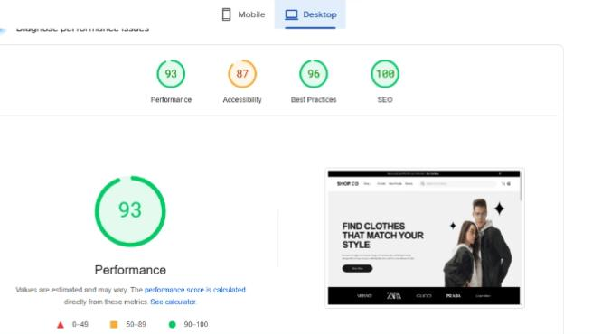

## **6. Staging Test Report**

| **Test Case ID** | **Test Description** | **Expected Outcome** | **Actual Outcome** | **Status** |
| --- | --- | --- | --- | --- |
| TC_001 | Product listings load correctly | Grid displays all products with details | ✅ Products displayed accurately | **Passed** |
| TC_002 | API response error handling | Displays an error message if API fails | ✅ Error message shown | **Passed** |
| TC_003 | Add to Cart functionality | Adds items and updates total price | ⚠ Issue with updating quantity | **Pending Fix** |
| TC_004 | Mobile responsiveness | Layout adapts to different screen sizes | ✅ Fully responsive | **Passed** |

🔗 [**Full Test Case Report - CSV**](https://github.com/Ayman-queen/Documentation_Marketplace_Builder_Hackathon-/blob/main/Testing_Report.csv)

## **7. Deployment Documentation & GitHub Organization**

### **Updated README.md File in GitHub**

📌 Documented:

* **Project Overview**
* **Installation & Setup Guide**
* **Deployment Instructions**
* **Testing & Performance Results**

**📂 Organized GitHub Repository Structure:**

/Clothing-Ecommerce-Website

│── /src # Source code (Next.js components, pages)

│── /public # Static assets (logos, images)

│── /screenshots # Performance & security test results

│── /Documentation # Test reports & deployment guides

│── README.md # Project summary

🔗 [**GitHub Repository**](https://github.com/Ayman-queen)

## **8. Expected Outcome**

✔ **Fully deployed staging environment on Vercel**  
✔ **Comprehensive testing reports with documented fixes**  
✔ **Secure API integrations and environment configurations**  
✔ **Optimized performance for real-world traffic**  
✔ **Well-structured GitHub repository with deployment instructions**

## **9. Final Submission Checklist**

✔ **Staging environment deployed successfully** ✅  
✔ **GitHub repository updated with documentation** ✅  
✔ **Test case report submitted** ✅  
✔ **Performance and security testing completed** ✅  
✔ **Final review conducted** ✅

## **10. Summary & Next Steps**

With **staging successfully deployed**, the **Clothing E-Commerce Website** is now **one step closer to production**.

* **Performance is optimized** for real-world use.
* **Security best practices** have been implemented to safeguard user data.
* **Thorough documentation** ensures a smooth transition to the live environment.

🚀 **Next Steps:**

* Address **pending issues** before final launch.
* Deploy the website to **production (PROD)**.
* Monitor real-time user interactions and optimize as needed.

### **📌 Submitted by:**

👤 **Ayman Shaheen**  
📅 **Date:** February 3, 2025  
🚀 **Project:** Clothing E-Commerce Website